Hollywood Movies Project:
Aims: To analyze the performance of Hollywood movies
Step 1;
Used R Studio to clean Hollywood Movies Dataset
R Script:
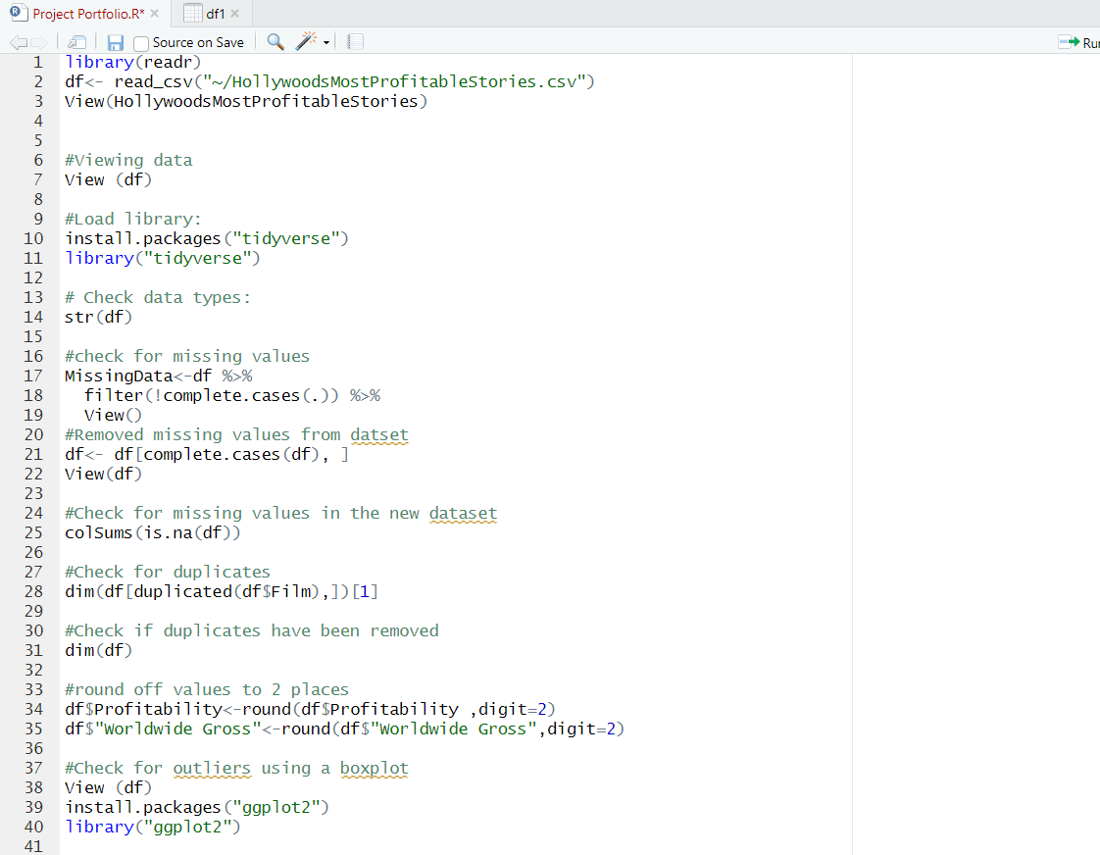
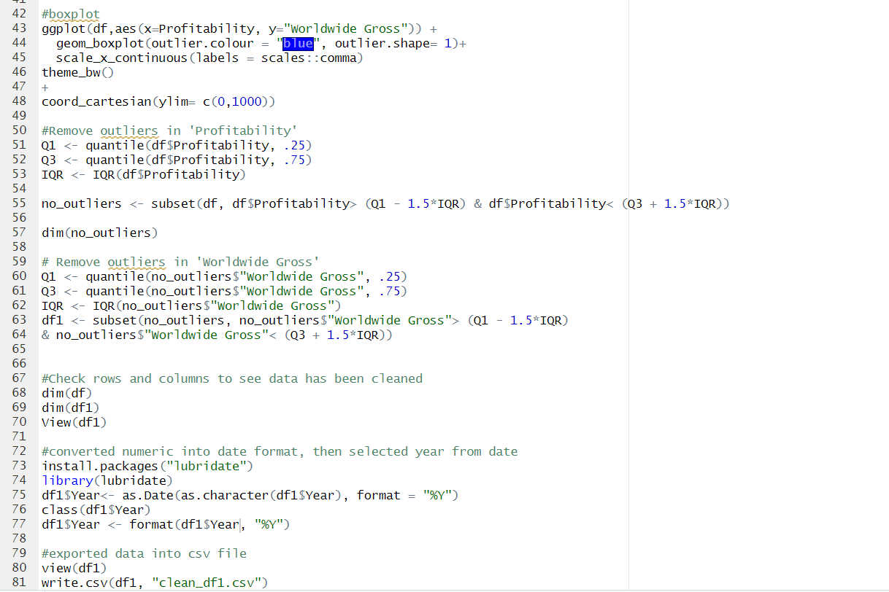
Step2) Imported Data into Tableau
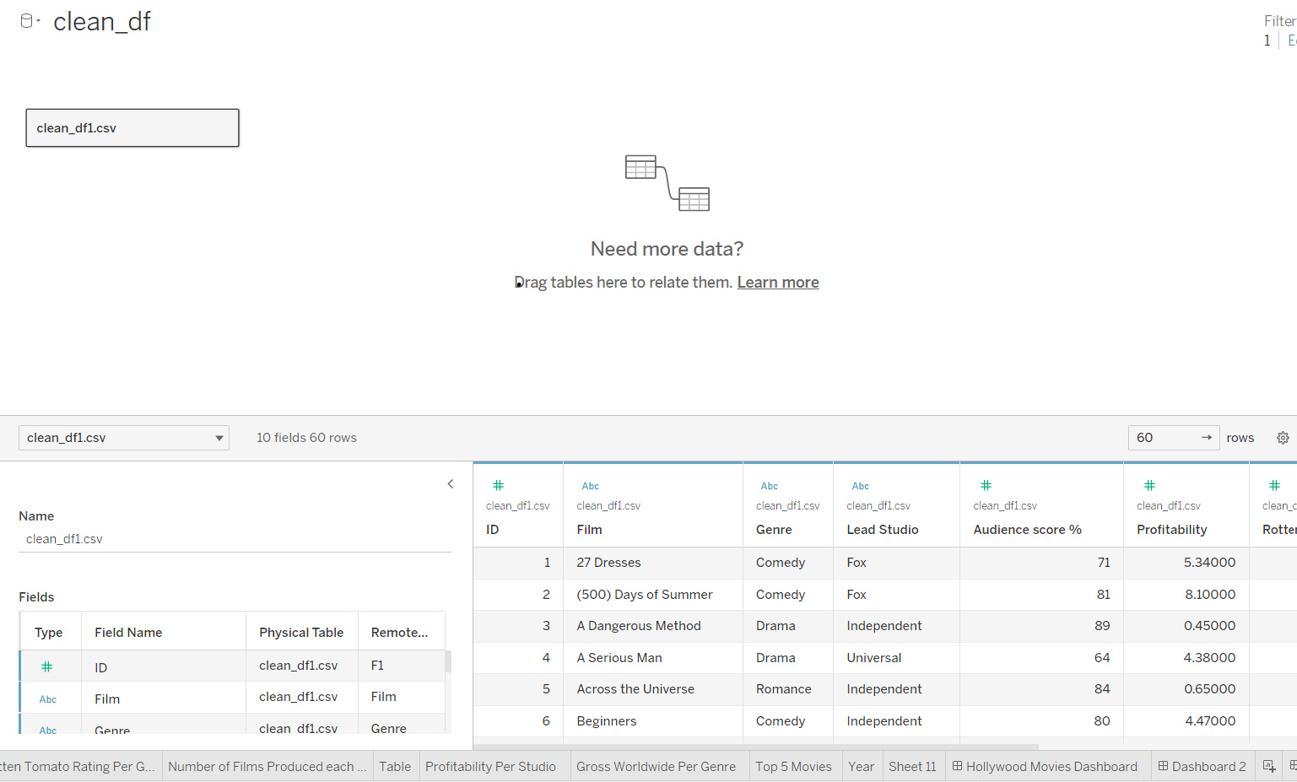
Step 3) Completed Visualisations:
Aims:
- The average Rotten Tomatoes ratings of each genre
- The number of movies produced per year
- The audience score for each film
- The profitability per studio
- The worldwide gross per genre

Dashboard :
https://app.powerbi.com/groups/me/reports/6fbdab13-8de1-4c60-b204-021d515d6f1f/ReportSection
